Experiment:2
Aim:
To write a Python program to solve the 8 Queens problem using the Backtracking technique, ensuring that no two queens attack each other.

Algorithm:
- Start the program.
- Initialize an empty chessboard of size 8 × 8.
- Place a queen in the first row.
- Check whether the position is safe (no other queen in the same column or diagonal).
- If the position is safe, place the queen and move to the next row.
- If no safe position is available, backtrack to the previous row and try another position.
- Repeat until all 8 queens are placed safely.
- Display the solution.
- Stop the program.

Code:
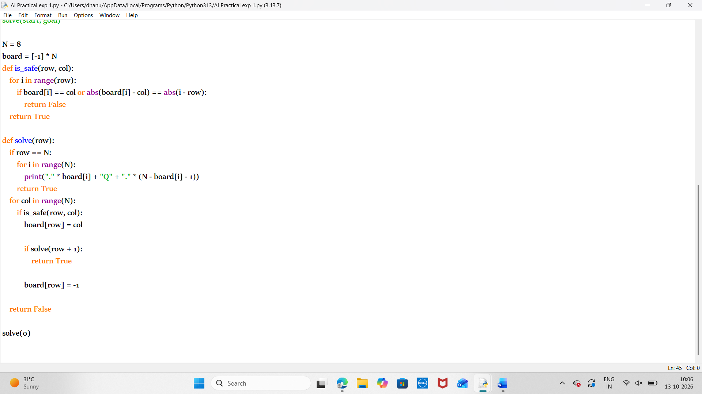

Output:
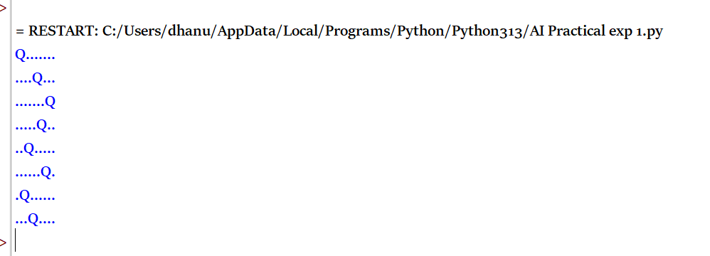
Result:
Thus the python program to solve 8 queen problem is executed successfully.

